## Getting Started with Django

**Summary**: in this tutorial, you’ll learn how to create a new Django project, understand the project structure, and launch the Django web app from a web browser.

##### Django overview

Django is a Python web framework that includes a set of components for solving common web development problems.

Django allows you to **rapidly develop web applications with less code** by taking advantage of its framework.

Django follows the **DRY (don’t repeat yourself)** principle, which allows you to maximize the code reusability.

Django uses the **MVT (Model-View-Template) pattern**, which is slightly similar to the **MVC (Model- View-Controller)** pattern.

The MVT pattern consists of three main components:

* **Model** – defines the data or contains the logic that interacts with the data in the database.
* **View** – communicates with the database via model and transfers data to the template for representing the data.
* **Template** – defines the template for displaying the data in the web browser.

The Django framework itself acts as a controller. The Django framework uses URL patterns that send the request to an appropriate view.

If you are familiar with **MVC**, the following are equivalent:

* **Template (T) is equivalent to View (V) in MVC**
* **View (V) is equivalent to Controller (C) in MVC**
* **Model (M) is equivalent to Model (M) in MVC**

In practice, you’ll often work with models, views, templates, and URLs in the Django application.

**Django helps you write software that is:**

Complete

Django follows the **"Batteries included" philosophy** and provides almost everything developers might want to do "out of the box". Because everything you need is part of the one "product", it all works seamlessly together, follows consistent design principles, and has extensive and up-to- date documentation.

Versatile

Django can be (and has been) used to build almost any type of website — from **content management systems and wikis, through to social networks and news sites.** It can work with

Secure

any client-side framework, and can deliver content in almost any format (including HTML, RSS feeds, JSON, and XML).

Internally, while it provides choices for almost any functionality you might want (e.g. several popular databases, templating engines, etc.), it can also be extended to use other components if needed.

Django helps developers avoid many common security mistakes by providing a framework that has been engineered to **"do the right things"** to protect the website automatically. For example, Django provides a secure way to manage user accounts and passwords**, avoiding common mistakes like putting session information in cookies where it is vulnerable** (instead cookies just contain a key, and the actual data is stored in the database) or **directly storing passwords rather** than a password hash.

*A password hash is a fixed-length value created by sending the password through a cryptographic hash function. Django can check if an entered password is correct by running it through the hash function and comparing the output to the stored hash value. However due to the "one-way" nature of the function, even if a stored hash value is compromised it is hard for an attacker to work out the original password.*

Django enables protection against many vulnerabilities by default, including SQL injection, cross- site scripting, cross-site request forgery and clickjacking (see Website security for more details of such attacks).

Scalable

Django uses a **component-based "shared-nothing" architecture** (each part of the architecture is independent of the others, and can hence be replaced or changed if needed). Having a clear separation between the different parts means that it can scale for increased traffic by adding hardware at any level: caching servers, database servers, or application servers. Some of the busiest sites have successfully scaled Django to meet their demands (e.g. **Instagram** and **Disqus**, to name just two).

Maintainable

Django code is written using design principles and patterns that encourage the creation of maintainable and reusable code. In particular, it makes use of the **Don't Repeat Yourself (DRY) principle** so there is no unnecessary duplication, reducing the amount of code. Django also promotes the grouping of related functionality into reusable "applications" and, at a lower level, groups related code into modules (along the lines of the Model View Controller (MVC) pattern).

Portable

Django is written in Python, which runs on many platforms. That means that you are not tied to any particular server platform, and can run your applications on many **flavors of Linux,**

**Windows, and macOS.** Furthermore, Django is well-supported by many web hosting providers, who often provide specific infrastructure and documentation for hosting Django sites.

## History:

Django was initially developed between **2003 and 2005** by a web team who were responsible for creating and maintaining newspaper websites.

After creating a number of sites, the team began to factor out and reuse lots of common code and design patterns.

This common code evolved into a **generic web development framework,** which was open-sourced as the **"Django" project in July 2005.**

Django has continued to grow and improve, from its first milestone release (1.0) in **September 2008 through to the version 5.0 in 2023.**

Each release has added new functionality and bug fixes, ranging from support for new types of databases, template engines, and caching, through to the addition of "generic" view functions and classes (which reduce the amount of code that developers have to write for a number of programming tasks).

# Django architecture

The following picture shows how Django manages the HTTP request/response cycle using its components:

Web Browser

Http Request

Http Response

Model

View

Template

URLs

Database

Text is not SVG - cannot display

* First, a web browser requests a page specified by a URL from a web server. The web server passes the HTTP request to Django.
* Second, Django matches the URL with URL patterns to find the first match.
* Third, Django calls the View that corresponds to the matched URL.
* Fourth, the view uses a model to retrieve data from the database.
* Fifth, the model returns data to the view.
* Finally, the view renders a template and returns it as an HTTP response.

Django web applications typically group the code that handles each of these steps into separate files:

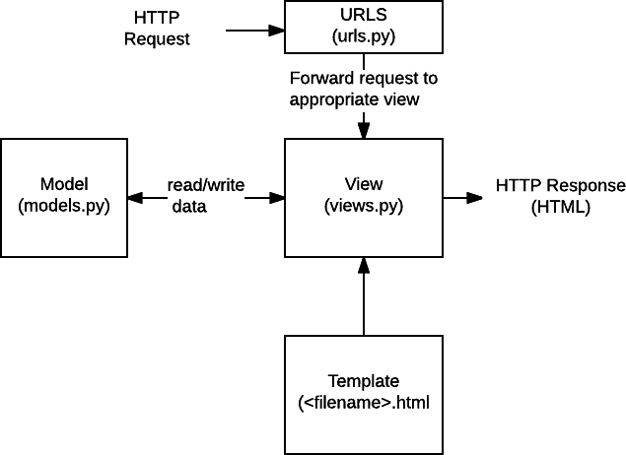

* **URLs:** While it is possible to process requests from every single URL via a single function, it is much more maintainable to write a separate view function to handle each resource. A URL mapper is used to redirect HTTP requests to the appropriate view based on the request URL. The URL mapper can also match particular patterns of **strings or digits that appear in a URL and pass these to a view function as data.**
* **View:** A view is a request handler function, which receives HTTP requests and returns HTTP responses. Views access the data needed to satisfy requests **via *models*, and delegate the formatting of the response to *templates*.**
* **Models:** Models are Python objects that define the structure of an application's data, and provide mechanisms to manage **(add, modify, delete)** and query records in the database.
* **Templates:** A template is a text file defining the structure or layout of a file (such as an HTML page), with placeholders used to represent actual content. A *view* can dynamically create an HTML page using an HTML template, populating it with data from a *model*. A template can be used to define the structure of any type of file; it **doesn't have to be HTML!**

## Install pip: Install command:

python -m ensurepip

## Check the installed version

pip --version

## Upgrade:

python3 -m pip install --upgrade pip

## Install Django:

pip install Django

python -m django --version

### Exploring Django commands

Django comes with a command-line utility program called **django-admin** that manages administrative tasks such as creating a new project and running the Django development server. To list all available Django commands, you execute the following django-admin command like this:

### django-admin

#### Output:

Type **'django-admin help <subcommand>'** for help on a specific subcommand. Available subcommands:

[django]

check

compilemessages

createcachetable

dbshell

diffsettings

dumpdata

flush

inspectdb

loaddata

makemessages

makemigrations

migrate

optimizemigration

runserver

sendtestemail

shell

showmigrations

sqlflush

sqlmigrate

sqlsequencereset squashmigrations

startapp

startproject

test

testserver

#### For now, we’re interested in the **startproject** command that creates a new Django project. The following startproject command creates a new project called django_project:

django-admin startproject django_project This command creates a django_project directory. Let’s explore the project structure:

cd django_project

The following shows the django_project structure:

├── django_project

| ├── asgi.py

| ├── settings.py

| ├── urls.py

| ├── wsgi.py

| └── init .py

└── manage.py

Here’s a quick overview of each file in the Django project:

* manage.py is a command-line program that you use to interact with the project like starting a development server and making changes to the database.

The django_project is a Python package that consists of the following files:

* init .py – is an empty file indicating that the django_project directory is a package.
* settings.py – contains the project settings such as installed applications, database connections, and template directories.
* Urls.py – stores a list of routes that map URLs to views.
* wsgi.py – contains the configurations that run the project as a web server gateway interface (WSGI) application with WSGI-compatible web servers.
* asgi.py – contains the configurations that run the project as an asynchronous web server gateway interface (AWSGI) application with AWSGI-compatible web servers.

# Running the Django development server

Django comes with a built-in web server that allows you to quickly run your Django project for development purposes.

The Django development web server will continuously check for code changes and reload the project automatically. However, you still need to restart the web server manually in some cases such as adding new files to the project.

To run the Django development server, you use the runserver command:

python manage.py runserver

Output:

Watching for file changes with StatReloader Performing system checks...

System check identified no issues (0 silenced).

...

Django version 4.1.1, using settings 'django_project.settings' Starting development server at http://127.0.0.1:8000/

Quit the server with CTRL-BREAK. Code language: plaintext (plaintext)

Once the server is up and running, you can open the web app using the URL listed in the output. Typically, the URL is something like this:

http://127.0.0.1:8000/

Now, you can copy and paste the URL to a web browser. It should show the following webpage:

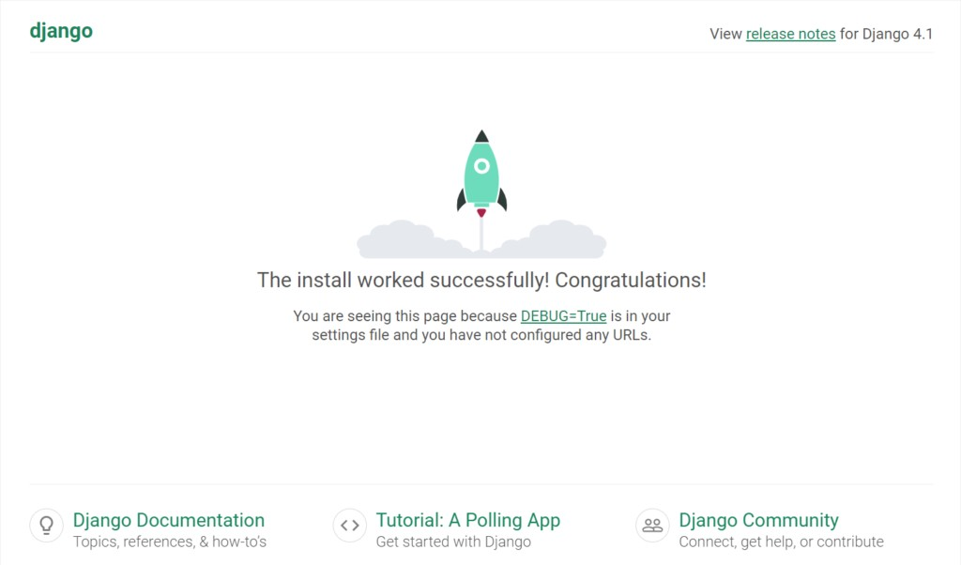

The urls.py contains a default route that maps /admin path with the admin.site.urls view:

from django.contrib import admin from django.urls import path

urlpatterns = [

path('admin/', admin.site.urls),

]

To open the admin page, you use the following URL:

http://127.0.0.1:8000/admin

It’ll show a login page:

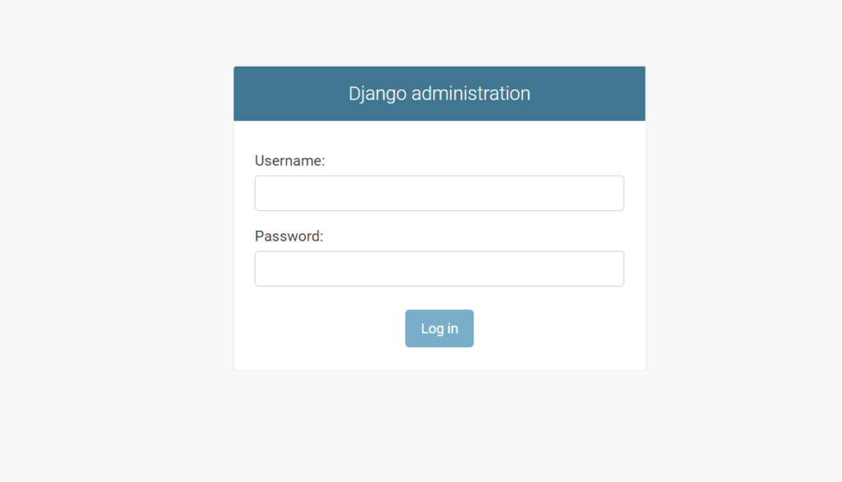

# Django projects and applications

In the Django framework:

* A project is a Django installation with some settings.
* An application is a group of models, views, templates, and URLs.

A Django project may have one or more applications. For example, a project is like a website that may consist of several applications such as blogs, users, and wikis.

Typically, you design a Django application that can be reusable in other Django projects. The following picture shows the structure of a Django project and its applications:

Django App 1

Django App 2

Django App N

|  |  |  |
| --- | --- | --- |
| Django Project | | |
| Text |  |  |
|  |
|  |
|  | |

is not SVG - cannot display

# Creating a blog application

To create an application, you use the starrtapp command as follows:

python manage.py startapp app_name

For example, you can create an application called blog using the startapp command like this:

python manage.py startapp blogß

The command creates a blog directory with some files:

├── blog

| ├── admin.py

| ├── apps.py

| ├── migrations

| ├── models.py

| ├── tests.py

| ├── views.py

| └── init .py

├── db.sqlite3

├── django_project

| ├── asgi.py

| ├── settings.py

| ├── urls.py

| ├── wsgi.py

| ├── init .py

| └── pycache

└── manage.py

# Registering an application

After creating an application, you need to register it to the project especially when the application uses templates and interacts with a database.

The blog app has the apps.py module which contains the BlogConfig class like this:

from django.apps import AppConfig

class BlogConfig(AppConfig):

default_auto_field = 'django.db.models.BigAutoField'

name = 'blog'

To register the blog app, you add the blog.apps.BlogConfig class to the INSTALLED_APPS list in the settings.py of the project:

INSTALLED_APPS = [

# ...

'blog.apps.BlogConfig',

]

Alternatively, you can use the app name like blog in the INSTALLED_APPS list like this:

INSTALLED_APPS = [

# ...

'blog',

]

# Creating a view

The views.py file in the blog directory comes with the following default code:

from django.shortcuts import render

The views.py will contain all the views of the application. A view is a function that takes

an HttpRequest object and returns an HttpResponse object. It’s equivalent to the controller in the MVC architecture.

To create a new view, you import the HttpResponse from the django.http into the views.py file and define a new function that accepts an instance of the HttpRequest class:

from django.shortcuts import render from django.http import HttpResponse

def home(request):

return HttpResponse('<h1>Blog Home</h1>')

In this example, the home() function returns a new HttpResponse object that contains a piece of HTML code. The HTML code includes an h1 tag.

The home() function accepts an instance of an HttpRequest object and returns

an HttpResponse object. It is called a function-based view. Later, you’ll learn how to create class- based views.

To map a URL with the home() function, you create a new file urls.py inside the blog directory and add the following code to the urls.py file:

from django.urls import path from . import views

urlpatterns = [

path('', views.home, name='posts'),

]

How it works.

First, import the path from django.urls module:

from django.urls import path

Second, import the views.py module from the current directory.

from . import views

Note that this is a relative import that imports the views module from the current directory.

Third, define a route that maps the blog URL with the home() function using the path() function. urlpatterns = [

path('', views.home, name='posts'),

]

The name keyword argument defines the name of the route. Later, you can reference the URL using the route name instead of the hard-code URL like blog/.

By using the name for the path, you can change the URL of the path to something else like my- blog/ in the urls.py instead of changing the hard-coded URL everywhere.

Note that the final argument of the path must be a keyword argument like name='posts'. If you use a positional argument like this:

from django.urls import path from . import views

urlpatterns = [

path('', views.home, 'posts'), # Error

]

you’ll get the following error:

TypeError: kwargs argument must be a dict, but got str.

To make the blog’s routes work, you need to include the urls.py of the blog application in the urls.py file of the Django project:

from django.contrib import admin

from django.urls import path, include *# new*

urlpatterns = [

path('admin/', admin.site.urls),

path('blog/', include('blog.urls')), # new

]

In the urls.py of the project, we import the include function from the django.urls and map the path of the blog to the blog.urls.

By doing this, when you navigate to http://127.0.0.1:8000/blog/, Django will run the home() function of the views.py module and returns a webpage that displays a h1 tag.

Before opening the URL, you need to start the Django development web server:

python manage.py runserver

When you navigate to http://127.0.0.1:8000/blog/, you’ll see a webpage that displays the Blog Home heading.

Here’s the flow:

* First, the web browser sends an HTTP request to the URL http://127.0.0.1:8000/blog/
* Second, Django executes the urls.py in the django_project directory. It matches the blog/ with the URL in the urlpatterns list in the urls.py. As a result, it sends '' to the urls.py of the blog app.
* Third, Django runs the urls.py file in the blog application. It matches the '' URL with

the views.home function and execute it, which returns an HTTP response that outputs a h1 tag.

* Finally, Django returns a webpage to the web browser.

##### Adding more routes

First, define the about() function in the views.py of the blog application:

from django.shortcuts import render from django.http import HttpResponse

def home(request):

return HttpResponse('<h1>Blog Home</h1>')

def about(request):

return HttpResponse('<h1>About</h1>')

Second, add a route to the urls.py file:

from django.urls import path from . import views

urlpatterns = [

path('', views.home, name='posts'),

path('about/', views.about, name='about'),

]

Third, open the URL http://127.0.0.1:8000/blog/about/, and you’ll see a page that displays the About page.

Now, if you open the home URL, you’ll see a page that displays a page not found with a 404 HTTP status code.

The reason is that the urls.py in the django_project doesn’t have any route that maps the home URL with a view.

To make the blog application the homepage, you can change the route from blog/ to '' as follows:

from django.contrib import admin

from django.urls import path, include

urlpatterns = [

path('admin/', admin.site.urls),

path('', include('blog.urls')),

]

If you open the URL http://127.0.0.1:8000, you’ll see the blog home page. And navigating to the URL http://127.0.0.1:8000/about/ will take you to the About page.

Django Templates

**Summary**: in this tutorial, you’ll learn how to create Django templates, pass data from view functions to templates, and display the data in the templates.

# Introduction to the Django templates

In the previous tutorial, you learned how to return a HttpResponse with a h1 tag from a view. To return a full HTML page, you’ll need to use a template.



A template is a file that contains the static and dynamic parts of a webpage. To generate the dynamic parts of the webpage, Django uses its specific template language called Django template language or DTL.

The Django template engine renders templates that contain variables, constructs, tags, and filters.

###### Variables

A variable is surrounded by {{ and }} . For example:

Hi {{name}}, welcome back!

In this template, the name is a variable. If the value of the name variable is John , the Django template engine will render the above template to the following text:

Hi John, welcome back!

If a variable is a dictionary, you can access the items of the dictionary using the dot notation

( dict_name.key ).

Suppose you have a person dictionary with two keys name and email :

person = {'name': 'John', 'email': 'john@pythontutorial.net'}

… you can access the values of the name and email keys of the person dictionary in the template like this:

{{ person.name }}

{{ person.email }}

###### Tags

Tags are responsible for outputting contents, serving a control structure if-else, for-loop, and getting data from a database.

Tags are surrounded by {% and %} . For example:

{% csrf_token %}

In this example, the csrf_token tag generates a token for preventing CSRF attacks. Some tags like if-else and for-loop require beginning and ending tags. For example:

{% if user.is_authenticated %} Hi {{user.username}}

{% endif %}

###### Filters

Filters transform the contents of variables and tags argument. For example, to capitalize each word of a string, you use the title filter like this:

{{ name | title }}

If the value of the name variable is john doe , then the title filter will transform it to the following:

John Doe

Some filters accept an argument. For example, to format a date of the joined_date variable in the Y-m-d format, you use the following filter:

{{ joined_date | date: "Y-m-d" }}

Here are the complete built-in template tags and filters.

###### Comments

The comments will look like this:

{*# This is a comment in the template #}*

The Django template engine will not render text inside the comment blocks.

# Django template examples

First, create a new directory called templates inside the blog directory:

mkdir templates

Second, create a blog directory inside the templates directory:

cd templates mkdir blog



app of the Django project.

Third, inside the templates/blog directory create two template files home.html and

about.html with the following contents.The

home.html file:

<!DOCTYPE html>

<html lang="en">

<head>

<meta charset="UTF-8">

<meta name="viewport" content="width=device-width, initial-scale=1.0">

<title>Home</title>

</head>

<body>

<h1>Home</h1>

</body>

</html>

The about.html file:

<!DOCTYPE html>

<html lang="en">

<head>

<meta charset="UTF-8">

<meta name="viewport" content="width=device-width, initial-scale=1.0">

<title>About</title>

</head>

<body>

<h1>About</h1>

</body>

</html>

It’s important to note that you should add the blog application to the INSTALLED_APPS list in the settings.py file to make the templates work. Typically, you do it immediately after creating the new Django application.

INSTALLED_APPS = [

*# ...*

'blog.apps.BlogConfig',

Fourth, open the views.py file and change the home() and about() view functions to thefollowing:

from django.shortcuts import render

def home(request):

return render(request, 'blog/home.html')

def about(request):

return render(request, 'blog/about.html')

In this views.py file, we import the render() function from the django.shortcuts .

The render() function accepts an HttpRequest object and a path to a template. It rendersthe template and returns an HttpResponse object.

Fifth, run the Django development server:

python manage.py runserver

Finally, open the URL http://127.0.0.1:8000/ and the URL http://127.0.0.1:8000/about/ , you’ll see full HTML pages that come from the home.htmland about.html templates.

###### Passing variables to a template

We’ll create dummy blog post data and pass it to the home.html template. Later, you’ll learn how to get the post data from the database.

The views.py will look like this:

from django.shortcuts import render

posts = [

{

'title': 'Beautiful is better than ugly', 'author': 'John Doe',

'content': 'Beautiful is better than ugly',

'published_at': 'October 1, 2022'

},

{

'title': 'Explicit is better than implicit', 'author': 'Jane Doe',

'content': 'Explicit is better than implicit',

'published_at': 'October 1, 2022'

}

]

def home(request): context = {

'posts': posts

}

return render(request, 'blog/home.html', context)

def about(request):

return render(request, 'blog/about.html')

How it works.

First, create a new list ( posts ) that stores the dummy post data.

Second, define a new dictionary context inside the home() function with the key posts

and pass it to the render() function as the third argument.

Inside home.html template, you can access the post data via the posts variable. The following home.html template that displays the posts:

<!DOCTYPE html>

<html lang="en">

<head>

<meta charset="UTF-8" />

<meta name="viewport" content="width=device-width, initial-scale=1.0" />

<title>Blog</title>

</head>

<body>

{% for post in posts %}

<h2>{{ post.title }}</h2>

<small>Published on {{ post.published_at }} by {{ post.author}}</smal

<p>{{ post.content }}</p>

{% endfor %}

</body>

</html>

How it works.

First, use a for loop to iterate over the posts variable. The for loop ends with

endfor . Both for and endfor are surrounded by {% and %} .

Second, place the value of each item in the dictionary using dot notation ( . ).

If you save the home.html and open the URL http://127.0.0.1:8000/ , you’ll see the postdata displayed on the page.

Besides the for loop, you can use another conditional statement like if-else . For example:

<!DOCTYPE html>

<html lang="en">

<head>

<meta charset="UTF-8" />

<meta name="viewport" content="width=device-width, initial-scale=1.0" />

<title>{% if title %} {{title}} {% else %} Blog {% endif %}</title>

</head>

<body>

</body>

{% for post in posts %}

<h2>{{ post.title }}</h2>

<small>Published on {{ post.published_at }} by {{ post.author}}</smal

<p>{{ post.content }}</p>

{% endfor %}

This example uses an if-else statement to show the title variable if it is available or the

Blog otherwise.

To pass the title variable to the home.html template, you add a new entry to the context

dictionary with the key title in the home() function like this:



def home(request): context = {

'posts': posts,

'title': 'Zen of Python'

return render(request, 'blog/home.html', context)

If you refresh the home URL http://127.0.0.1:8000/ , you’ll see the new title.

Typically, a website has some common sections like a header, footer, and sidebar. To avoid repeating them in every template, you can use a base template.

# Creating a base template

First, create a new templates directory in the project directory (not the blog app):

├── blog

├── db.sqlite3

├── django_project

├── manage.py

├── templates

└── users

Next, add the template directory to the TEMPLATES option in the settings.py file of theproject:

TEMPLATES = [

'BACKEND': 'django.template.backends.django.DjangoTemplates', 'DIRS': [BASE_DIR / 'templates' ],

'APP_DIRS': True, 'OPTIONS': {

'context_processors': [ 'django.template.context_processors.debug', 'django.template.context_processors.request', 'django.contrib.auth.context_processors.auth', 'django.contrib.messages.context_processors.messages',

],

},

},



Then, create base.html in the templates directory with the following code:

<!DOCTYPE html>

<html lang="en">

<head>

<meta charset="UTF-8" />

<meta name="viewport" content="width=device-width, initial-scale=1.0" />

<title>{% if title %} {{title}} {% else %} Blog {% endif %}</title>

</head>

<body>

{% block content %}

2/15/24, 11:24 AM Django Templates

{% endblock %}

</body>

</html>

The base.html is served as the base template for other templates. The name of the base template can be anything like main.html .

After that, change the home.html template inside the templates/blog directory as follows:

{% extends 'base.html' %}

{% block content %}

<h1>My Posts</h1>

{% for post in posts%}

<h2>{{ post.title }}</h2>

<small>Published on {{ post.published_at }} by {{ post.author}}</small>

<p>{{ post.content }}</p>

{% endfor%}

{% endblock %}

The home.html extends the base.html template using the extends tag. The home.html

template has its section for the content block.

Also, change the about.html template that extends the base.html template:

{% extends 'base.html' %}

{% block content %}

<h1>About</h1>

{% endblock content %}

Finally, restart the Django development server and open URL http://127.0.0.1:8000/ , andyou’ll see the changes.

# Configure static files

24/14

2/15/24, 11:24 AM Django Templates

The static files are CSS, JavaScript, and image files that you use in the templates. To use the static files in the templates, you follow these steps:

First, create a static directory inside the project directory:

mkdir static

The project directory will look like this:

├── blog

├── db.sqlite3

├── manage.py

├── mysite

├── static

└── templates

Second, set the STATICFILES_DIRS in the settings.py after the STATIC_URL file so thatDjango can find the static files in the static directory:

STATIC_URL = 'static/'

STATICFILES_DIRS = [BASE_DIR / 'static']

Third, create three directories js , css , and images directory inside the static directory:

├── static

| ├── css

| ├── images

| └── js

Fourth, create style.css inside the CSS directory with the following contents.

h1{

color:#0052EA

25/14

2/15/24, 11:24 AM Django Templates

form {

max-width: 400px;

}

label, input, textarea, select{ display:block; width:100%;

}

input[type="submit"]{

display:inline-block; width:auto;

}

.errorlist {

padding:0; margin:0;

}

.errorlist li{

color:red;

list-style:none;

}

.alert{

}

padding:0.5rem;

.alert-success{

background-color: #dfd

}

.alert-error{

background-color:#ba2121; color:#fff;

}



26/14

2/15/24, 11:24 AM Django Templates

Fifth, create the app.js inside the js directory with the following code:

setTimeout(() => { alert('Welcome to my site!');

}, 3000);

This code shows an alert after the page is loaded for 3 seconds.

Sixth, edit the base.html template to load the style.css and app.js files:

{%load static %}

<!DOCTYPE html>

<html lang="en">

<head>

<meta charset="UTF-8" />

<meta name="viewport" content="width=device-width, initial-scale=1.0" />

<link rel="stylesheet" href="{% static 'css/style.css' %}" />

<script src="{% static 'js/app.js' %}" defer></script>

<title>My Site</title>

</head>

<body>

{%block content%}

{%endblock content%}

</body>

</html>

Seventh, restart the Django development server, open the URL http://127.0.0.1:8000/ , and you’ll see that the color of the heading changes according to the CSS rule.

Also, you’ll see an alert after about 3 seconds because the JavaScript code in the app.js

runs:

27/14

2/15/24, 11:24 AM

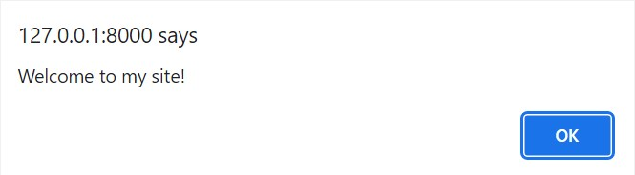

Since we’re not focusing on the JavaScript part, you can remove the code in the

app.js file tocontinue the next tutorial.

# Summary

A Django template contains both static and dynamic parts of a web page. Django uses Django Template Language (DTL) by default to create templates. Use {{ variable_name }} to display the value of the variable_name in a template.Use {% control_tag %} to include a control tag in a template.

Use the static tag to load the static files including CSS, JavaScript, and images.

28/14